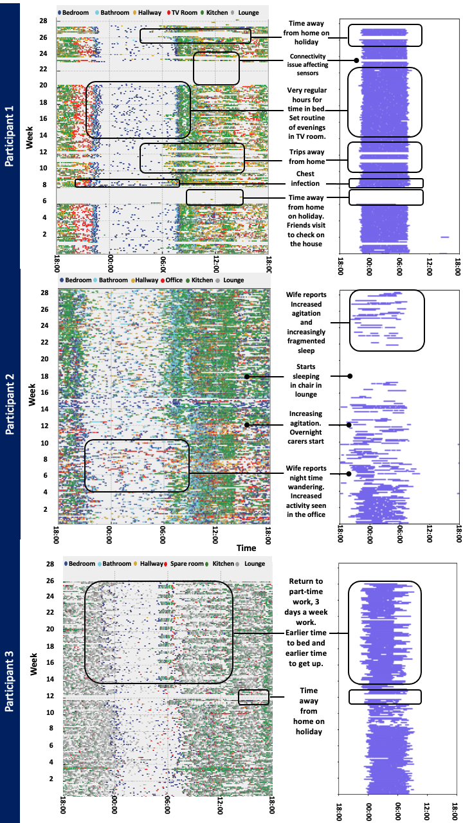

*Figure 4.1 Sensor mappings for P1-P3.*

The figures above present 26 weeks of data passively collected from passive infrared sensors (PIRs) and bed mats. In the scatter plot on the left-hand side, each dot signifies movement that activates a sensor. Different colours indicate sensor activation in various rooms, with the key provided at the top of the diagram. The Y-axis represents the weeks, while the X-axis denotes the time of day. These plots illustrate distinct patterns of movement throughout the household over the course of the day. The raster plots on the right-hand side display bed occupancy, indicating the time spent in bed. Similarly, the Y-axis shows the weeks, and the X-axis represents the time of day. The figures include annotations based on information obtained from weekly phone calls with the participant or their carer.

**

*Figure 4.2 Sensor mappings for P4.*

The figures above present 26 weeks of data passively collected from passive infrared sensors (PIRs) and bed mats. In the scatter plot on the left-hand side, each dot signifies movement that activates a sensor. Different colours indicate sensor activation in various rooms, with the key provided at the top of the diagram. The Y-axis represents the weeks, while the X-axis denotes the time of day. These plots illustrate distinct patterns of movement throughout the household over the course of the day. The raster plots on the right-hand side display bed occupancy, indicating the time spent in bed. Similarly, the Y-axis shows the weeks, and the X-axis represents the time of day. The figures include annotations based on information obtained from weekly phone calls with the participant or their carer.

*Figure 4.3 Sensor mappings for P5.*

The figures above present 27 weeks of data passively collected from passive infrared sensors (PIRs) and bed mats. In the scatter plot on the left-hand side, each dot signifies movement that activates a sensor. Different colours indicate sensor activation in various rooms, with the key provided at the top of the diagram. The Y-axis represents the weeks, while the X-axis denotes the time of day. These plots illustrate distinct patterns of movement throughout the household over the course of the day. The raster plots on the right-hand side display bed occupancy, indicating the time spent in bed. Similarly, the Y-axis shows the weeks, and the X-axis represents the time of day. The figures include annotations based on information obtained from weekly phone calls with the participant or their carer.

*Figure 4.4 Sensor mappings for P6.*

The figures above present 24 weeks of data passively collected from passive infrared sensors (PIRs) and bed mats. In the scatter plot on the left-hand side, each dot signifies movement that activates a sensor. Different colours indicate sensor activation in various rooms, with the key provided at the top of the diagram. The Y-axis represents the weeks, while the X-axis denotes the time of day. These plots illustrate distinct patterns of movement throughout the household over the course of the day. The raster plots on the right-hand side display bed occupancy, indicating the time spent in bed. Similarly, the Y-axis shows the weeks, and the X-axis represents the time of day. The figures include annotations based on information obtained from weekly phone calls with the participant or their carer.

*Figure 4.5 Sensor mappings for P7.*

The figures above present 29 weeks of data passively collected from passive infrared sensors (PIRs) and bed mats. In the scatter plot on the left-hand side, each dot signifies movement that activates a sensor. Different colours indicate sensor activation in various rooms, with the key provided at the top of the diagram. The Y-axis represents the weeks, while the X-axis denotes the time of day. These plots illustrate distinct patterns of movement throughout the household over the course of the day. The raster plots on the right-hand side display bed occupancy, indicating the time spent in bed. Similarly, the Y-axis shows the weeks, and the X-axis represents the time of day. The figures include annotations based on information obtained from weekly phone calls with the participant or their carer.

*Figure 4.6 Sensor mappings for P8*.

The figures above present 28 weeks of data passively collected from passive infrared sensors (PIRs) and bed mats. In the scatter plot on the left-hand side, each dot signifies movement that activates a sensor. Different colours indicate sensor activation in various rooms, with the key provided at the top of the diagram. The Y-axis represents the weeks, while the X-axis denotes the time of day. These plots illustrate distinct patterns of movement throughout the household over the course of the day. The raster plots on the right-hand side display bed occupancy, indicating the time spent in bed. Similarly, the Y-axis shows the weeks, and the X-axis represents the time of day. The figures include annotations based on information obtained from weekly phone calls with the participant or their carer.

*Figure 4.7 Sensor mappings for P9.*

The figures above present 28 weeks of data passively collected from passive infrared sensors (PIRs) and bed mats. In the scatter plot on the left-hand side, each dot signifies movement that activates a sensor. Different colours indicate sensor activation in various rooms, with the key provided at the top of the diagram. The Y-axis represents the weeks, while the X-axis denotes the time of day. These plots illustrate distinct patterns of movement throughout the household over the course of the day. The raster plots on the right-hand side display bed occupancy, indicating the time spent in bed. Similarly, the Y-axis shows the weeks, and the X-axis represents the time of day. The figures include annotations based on information obtained from weekly phone calls with the participant or their carer.

*Figure 4.8 Sensor mappings for P10.*

The figures above present 28 weeks of data passively collected from passive infrared sensors (PIRs) and bed mats. In the scatter plot on the left-hand side, each dot signifies movement that activates a sensor. Different colours indicate sensor activation in various rooms, with the key provided at the top of the diagram. The Y-axis represents the weeks, while the X-axis denotes the time of day. These plots illustrate distinct patterns of movement throughout the household over the course of the day. The raster plots on the right-hand side display bed occupancy, indicating the time spent in bed. Similarly, the Y-axis shows the weeks, and the X-axis represents the time of day. The figures include annotations based on information obtained from weekly phone calls with the participant or their carer.

*Figure 4.9 Sensor mappings for P11.*

The figures above present 28 weeks of data passively collected from passive infrared sensors (PIRs) and bed mats. In the scatter plot on the left-hand side, each dot signifies movement that activates a sensor. Different colours indicate sensor activation in various rooms, with the key provided at the top of the diagram. The Y-axis represents the weeks, while the X-axis denotes the time of day. These plots illustrate distinct patterns of movement throughout the household over the course of the day. The raster plots on the right-hand side display bed occupancy, indicating the time spent in bed. Similarly, the Y-axis shows the weeks, and the X-axis represents the time of day. The figures include annotations based on information obtained from weekly phone calls with the participant or their carer.